**Lab Sheet 05**

1.

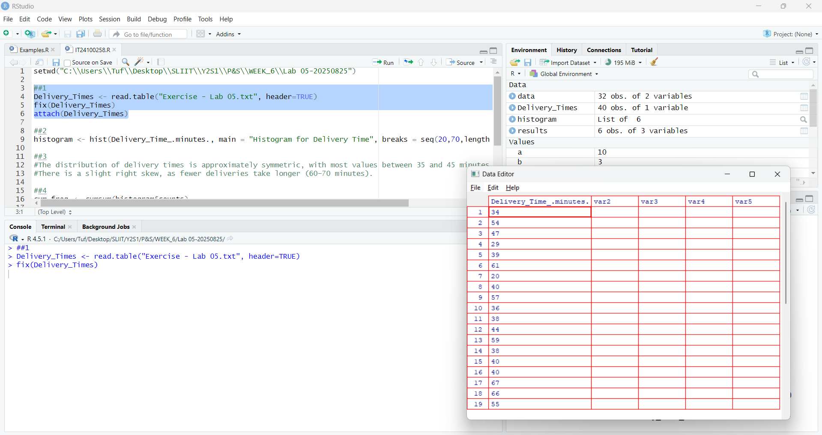

2.

3. Most delivery times are between 35 and 45 minutes. There are fewer very short (20–25 min) and very long (60–70 min) deliveries. The shape is mostly symmetric but slightly skewed to the right.

4.

